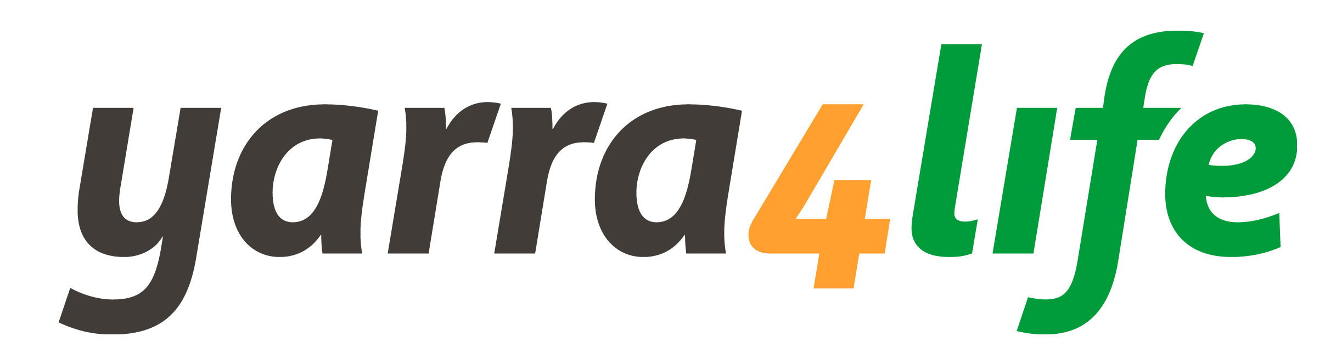
Yarra4Life Coordination Committee
Nomination form 2020

To nominate for a position on the Yarra4Life Coordination Committee, please complete your details below:
Title: (Dr. Mr. Mrs. Ms.) | Name:
Postal Address:
Phone: |  | Mobile:
Email:

Organisation:

Position:

Relevant knowledge, qualifications or credentials: (should relate to one or more of the following disciplines or activities - land management, primary production, biodiversity protection, revegetation, community education, research and development, business management, marketing and financial management, cultural heritage)

Signature:
Date: / / 2020

For further information go to www.yarra4life.com.au or contact the Yarra4Life Coordinator, Kacie Melfi on 0439 366 108.

To submit your nomination email a signed copy to kacie.melfi@ppwcma.vic.gov.au

or post the form to:

Yarra4Life Coordinator
PPWCMA
Level 1, 454 - 472 Nepean Hwy
Frankston, VIC 3199

